Scenario

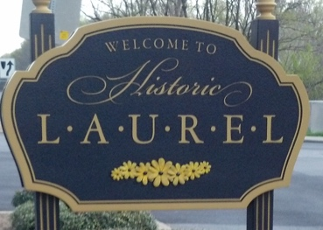
Five times since 2006, Ellicott City & Columbia have been ranked in the top 10 places to live by Money Magazine. Howard County officials are trying to use this fact to boost international tourism. Now you’ve been asked by Howard County officials to make a tourist map in French of Laurel. You need to draw a tourist map of Laurel and write a description of the area, mentioning places that tourists may be interested in.

You should consider including:
- The names of streets, bridges, rivers, etc. in your map
- Modes of transport in your description (by car, etc.)
- Descriptions of where places are located (behind, in front of, etc.)
- Give directions from how to get one from place (EX: the mall in Columbia) to another point of interest (EX: Old Ellicott City)
Feel free to include any other information you would think would be helpful for international visitors to know about Ellicott City & Columbia.

Scenario

Five times since 2006, Ellicott City & Columbia have been ranked in the top 10 places to live by Money Magazine. Howard County officials are trying to use this fact to boost international tourism. Now you’ve been asked by Howard County officials to make a tourist map in French of Laurel. You need to draw a tourist map of Laurel and write a description of the area, mentioning places that tourists may be interested in.

You should consider including:
- The names of streets, bridges, rivers, etc. in your map
- Modes of transport in your description (by car, etc.)
- Descriptions of where places are located (behind, in front of, etc.)
- Give directions from how to get one from place (EX: the mall in Columbia) to another point of interest (EX: Old Ellicott City)
Feel free to include any other information you would think would be helpful for international visitors to know about Ellicott City & Columbia.

---

